1. [**http://test.emsccv3.extramarks.com/school_lms/public/assessnew/apiVersion1/sudent-dashboard-api**](http://test.emsccv3.extramarks.com/school_lms/assessnew/apiVersion1/sudent-dashboard-api)

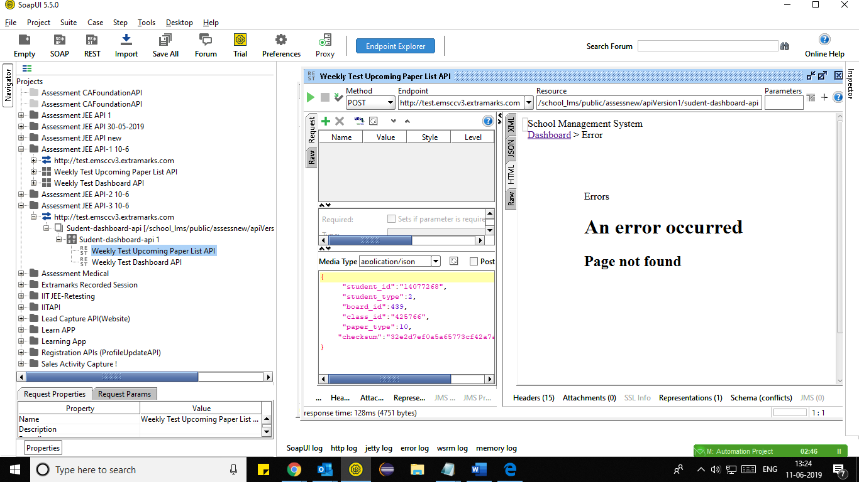

2. [**http://test.emsccv3.extramarks.com/school_lms/public/assessnew/apiVersion1/**](http://test.emsccv3.extramarks.com/school_lms/public/assessnew/apiVersion1/sudent-dashboard-api)**weekly-test-dashboard-api**

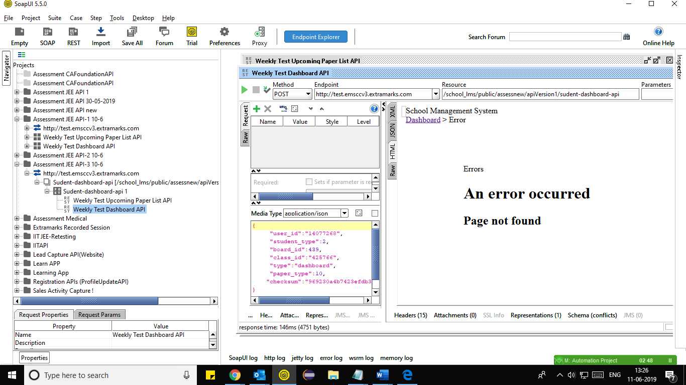

3. **API Url:** [**http://test.emsccv3.extramarks.com/school_lms/public/api/v1.0/jee**](http://test.emsccv3.extramarks.com/school_lms/public/api/v1.0/jeeadvance)**test**

